**BWT WEEK 2**

**ML/DL TRACK**

**Task: 1**

I made a dictionary and added name, age, email and fav number.

But for Email I added validation test using if-else condition.

Then printed all the info in a message. 😊

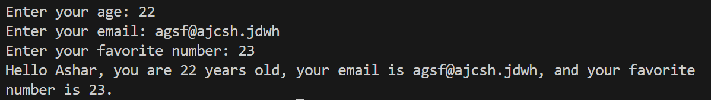

**Task: 2**

An input is taken from user which is passed to a function that uses modulo 2 to check if the number is even or odd and returns a bool value

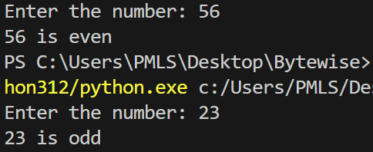

**Task: 3**

User enters the temp and measure and passes it to a function which converts into the other type of temp and returns it to be printed.

Also a side condition if there is an invalid scale, if it is, it recurses the function as to input again.

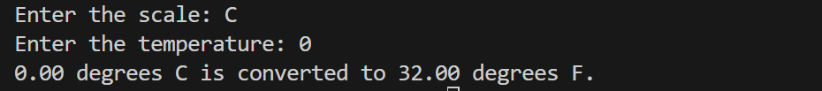

**Task: 4**

I took a list of numbers and user inputs 5 numbers by a loop. The list goes to a function which uses min max functions to find min or max values and returns them to be printed.

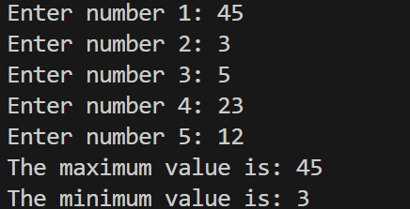

**Task: 5**

A dictionary is returned from a function in which user inputs students names, age and grades while name being the defining? Value  
and later they are printed out

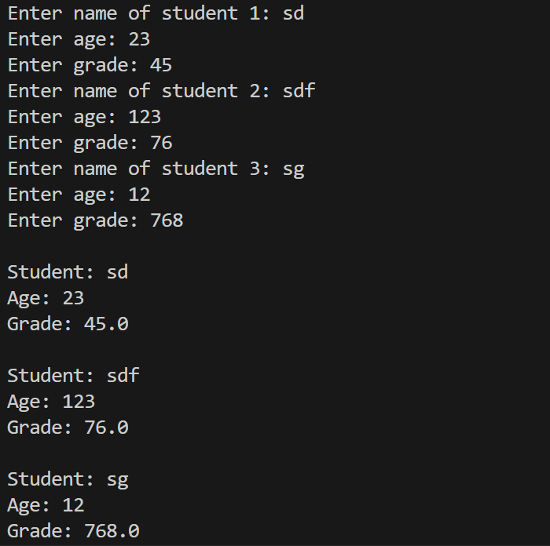

**Task: 6**

I initiated an inventory(dict) with “10 mangoes, 10 apples, 0 oranges”

Then asked user to update the type of fruit and the quantity to be added or subtracted

All 3 go to the function. Now if the user added a new item, it is added in the dictionary

If user removes the item more than the avaliable units it gives them an error and asked them to do it again. Otherwise it just updates the new quantity.

As an added perk I added all this is an infinite loop so list could be updated again n again just to play idk

